Project 9-3: Customer Viewer

Objectives
Use concepts from Chapter 9 and class discussion on csv files to complete Project 9-3

Description
Create an object-oriented program that reads a list of Customer objects from a CSV file and allows the user to enter the data for a customer by specifying the customer’s ID.

Requirements
- Your instructor should provide a CSV file named customers.csv that contains customer data. The file internal format is as follows:
1st line is header line – no customer information
Remaining lines contain the following information in order: cust_id,first_name,last_name,company_name,address,city,state,zip
- Use a Customer class to store the customer data. This class should include these attributes: id, firstName, lastName, company, address, city, state, zip.
- In addition, this class should include a property or method that returns the full address. This address should have three lines if the company attribute is empty or four lines if the company attribute is not empty.
- Create a function that reads the customer data from a CSV file and creates Customer objects from it.
- To find the customer with the specified ID, you need to loop through each Customer object in the list of Customer objects and check whether the specified ID matches the ID stored in the Customer object.
- If the specified ID isn’t found, display an appropriate message.
- The expected output images provide the format for the program output.
- The program should loop until the user requests to exit the program.

Expected Output
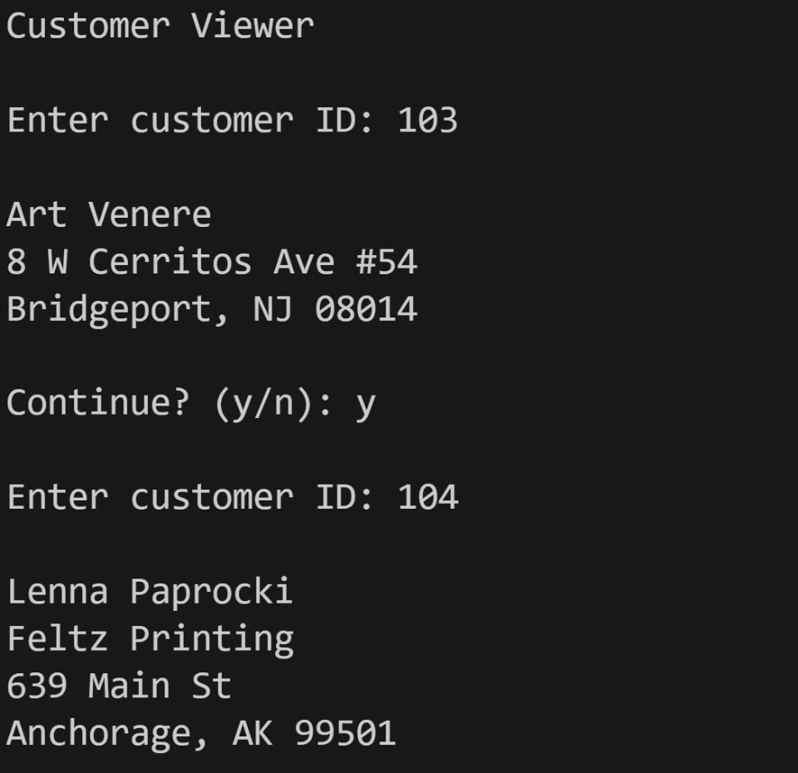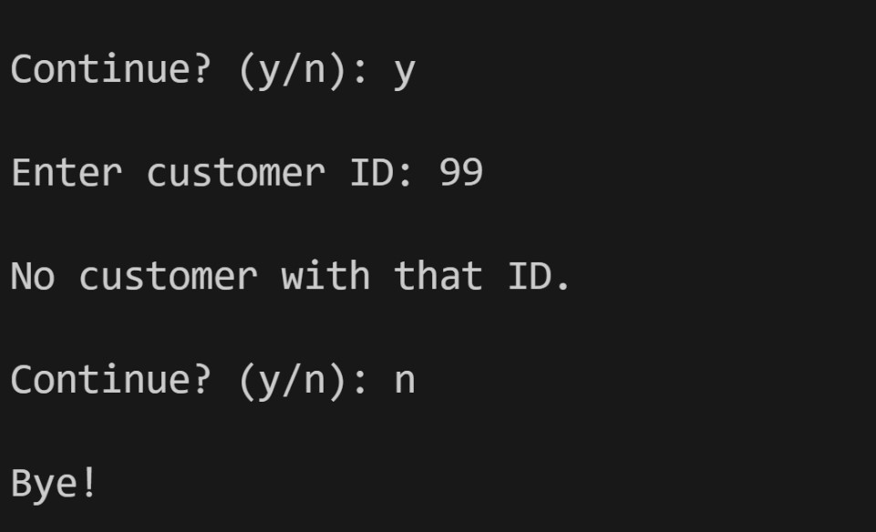

Table 1 - Grade Breakdown
Grading element | Point
File naming convention | 5
Comments (Minimum file header comments and interior code) | 10
Use customer class (appropriate attributes and methods included) | 30
Reads csv file correctly | 10
Save data correctly to a csv file | 10
Code displays appropriate output | 15
Code loops until user indicates address list management complete | 10
PEP 8 compliant | 10
Code does not compile | -50
Total Possible points | 100

